Locals Hotels Stafford

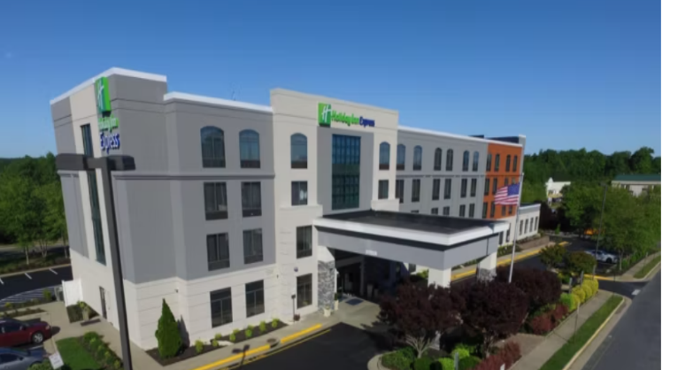15 Salisbury Drive, I-95 Exit 143B, Stafford, VA 22554 Phone 877 859 5095 Holiday Inn

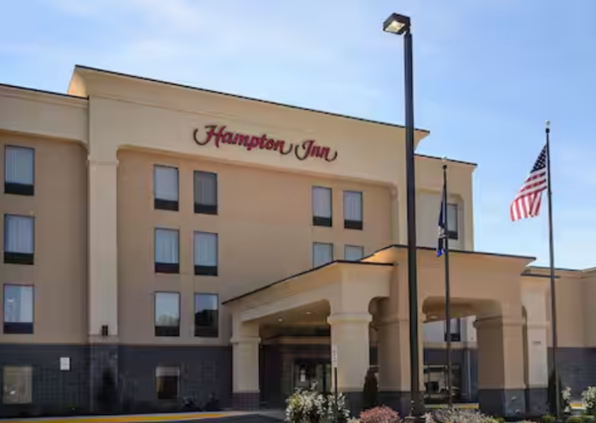 2965 Richmond Hwy, Stafford, VA 22554 Exit 143A Phone 540 657-0999 Hampton Inn

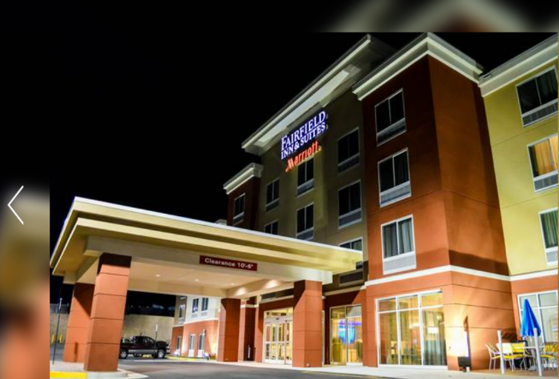2784 Richmond Hwy Stafford VA 22556 Exit 143A Phone 833-425-1192 Fairfield Inn